Dear Madam, Sir,
Please be advised that Belgian diamond traders are subject to Belgian anti-money laundering legislation and obliged to fully cooperate with the implementation of the Law and the Regulations.
Diamond traders are legally obliged by the law of 18 September 2017 preventing money laundering and financing of terrorism and limiting the use of cash to process your personal data to comply with our "know-your-customer" obligations. For more information on the processing of your personal data, please contact us so that we could provide you of our privacy statement/policy.
As a basic principle, Belgian diamond dealers are obliged to identify their clients and, in case of an elevated risk, also their suppliers and verify the identification documents received before entering in a business relationship or executing a transaction.

Therefore please provide your Belgian diamond supplier (or client) with the requested documentation including the completed form below :

- Company details :

  - Name of company : ………………………………………………………………………………………………………..
  - Type of company : …………..……………………………………………………………………….............................
  - Date of incorporation : …………..……………………………………………………………………….....................
  - VAT-number or official company registration number in your country : ………………………….
  - Registered office address : …………..………………………………………………………………………………...
……………………………………………………………………………………………………………………………………...
  - Operational address (if different): ………………………………………………………………………………..
…………..………………………………………………………………………………..........…………………………………..
  - Telephone number : …………….…………..…………………………………………………………………………….
  - E-mail : …………..……………………………………………………………….…………..………………………………...
  - Name(s) of official representative(s) : …………..………………………………………………………………..
……………………………………………………………………………………………………………………………………...
- Membership of professional organization(s) : ………………………………………………………………
……………………………………………………………………………………………………………………………………...

- List of the names and first names of the board of directors : together with other documents (e.g. official publications) by means of which can be demonstrated/proven that the person (persons) in question is (are) (a) director(s) (if not already mentioned in the legal incorporation documents (below))

Name + first name director(s) : ………………………………………………………………………………………………….
…………………………………………………………………………………………………………………………………………………
- List of the names and first names of the ultimate beneficial owner(s) of your company and if possible, documents proving that these are the ultimate beneficiaries (such as the shareholder register, organizational chart, bylaws…). You need not fill this in if your company is a public company.
Name + first name,- (and if possible, date of birth, place of birth and address) of ultimate beneficiary(ies):
……………………………………………………………………………………………………………………………………………..
……………………………………………………………………………………………………………………………………………..

- Politically exposed persons : is one of the company members related to a politically exposed person or is one of the company members a politically exposed person ?
  - No
  - Yes. Please clarify title and function : ………………………………………………………………………
…………………………………………………………………………………………………………………………………

  - Yes. Please clarify the source of your funds (e.g. do the financial resources with which you conduct this payment stem from your company’s ordinary operating funds and can you confirm that these do not stem from criminal activities) : …………………………………… …………………………………………………………………………………………………………………………………

- If you are located in a country with an elevated risk (indicated as per FATF and the European Commission), please provide the source of your financial resources (e.g. do the financial resources with which you conduct this payment stem from your company’s ordinary operating funds and can you confirm that these do not stem from criminal activities?) and confirm that your credit institution applies vigilance norms which are not less strict than the norms established in the Belgian anti-money laundering legislation: ………………………………...............................................................................................................................................................
………………………………………………………………………………………………………………………………………………….

- Please attach enclosed legal incorporation documentation of your company (statutes / by-laws)
The most recent version of your company’s certificate of incorporation or articles of association (or equivalent documentation depending on the jurisdiction which at least sets out company name and registered office).

- Payments

Please confirm that you will execute the payment of the invoice from your company and that you will not let a third party execute the payment: …………………………………………………………………………….

- Please attach enclosed a proof of identity of an official representative of your company:

      - For Belgian citizens: copy of his/her ID, or a valid proof of registration in the foreigners’ register, or a valid document issued by a Belgian public authority which states that this person is legally residing in Belgium, which contains at least, surname, first name, date & place of birth, and if possible address.

      - For foreign citizens: valid proof of ID, a valid passport, or possibly driving license or any other official document with photo which can be used as identification which contains at least, surname, first name, date & place of birth, and if possible address.

(The Belgian government accepts “PAN-cards” and “Certificates of IEC Codes” for Indian citizens. For other alternatives, contact the AML helpdesk.)

- A document that indicates that the official representative of your company has the power to represent the company, e.g. through a proxy (if not already mentioned in the legal incorporation documents)

I declare to the best of my knowledge that the above completed information and the documents enclosed are true and correct.

Place and date : ……………………………………………………………..
Authorized signature : ……………………………………………………

Antwerp World Diamond Centre represents the Belgian diamond sector and provides assistance to the Belgian diamond traders with the implementation of the Belgian anti-money laundering legislation. If you have questions regarding this legislation or you are not sure which identification documents to provide exactly, please feel free to contact the AML & Compliance Helpdesk @ AWDC: Trissia Stavropoulos, Head of Compliance trst@awdc.be or 0032/3.222.05.03.

We thank you in advance for your cooperation.

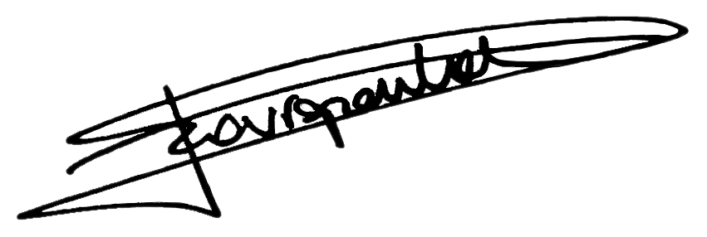
Trissia STAVROPOULOS
Head of Compliance

Law: Law d.d. 18 September 2017 preventing money laundering and financing of terrorism and limiting the use of cash (“anti-money laundering law”).
The ULTIMATE BENEFICIAL OWNER is the natural person that is ultimate owner or has ultimate say over the client: - Natural person owns 25% or more of the shares or voting rights in your client’s company - Natural person has control by any other means - Who has the right to appoint or remove a majority of the members of the administrative, management or supervisory body - Who, pursuant to an agreement with other shareholders in or members of that undertaking (a subsidiary undertaking), controls alone, a majority of shareholders' or members' voting rights in that undertaking 3. Natural person that is a member of the management of the company (e.g. CEO) – in case all other means above are exhausted And/or, if applicable : The natural person for whose account a transaction or business relationship is entered into, if this is concluded for the account of someone else than the natural person/company whom one is dealing with - Natural person who benefits from the transaction - Natural person who has an impact on the execution of the transaction.
POLITICALLY EXPOSED PERSONS cover heads of state, heads of government, ministers and secretaries of state; members of parliament; members of supreme courts, constitutional courts and other high courts that make decisions against which typically no further appeal is possible except in exceptional circumstances; members of audit institutions and of the boards of central banks; ambassadors, envoys and high-ranking military officers; members of administrative, directorial or supervisory bodies of public enterprises, as well as natural persons who have held a politically prominent position, immediate family members and close associates.

